Module 7

Question 1
Step 1: Creating a new ASP.NET Core Web Api

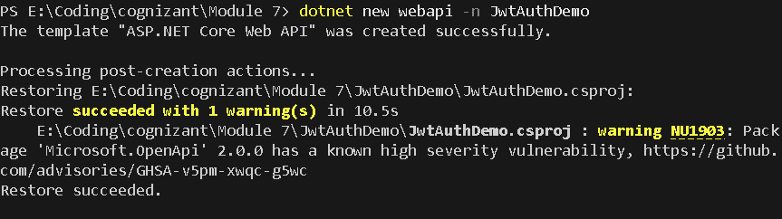

Step 2: Install NuGet Packages
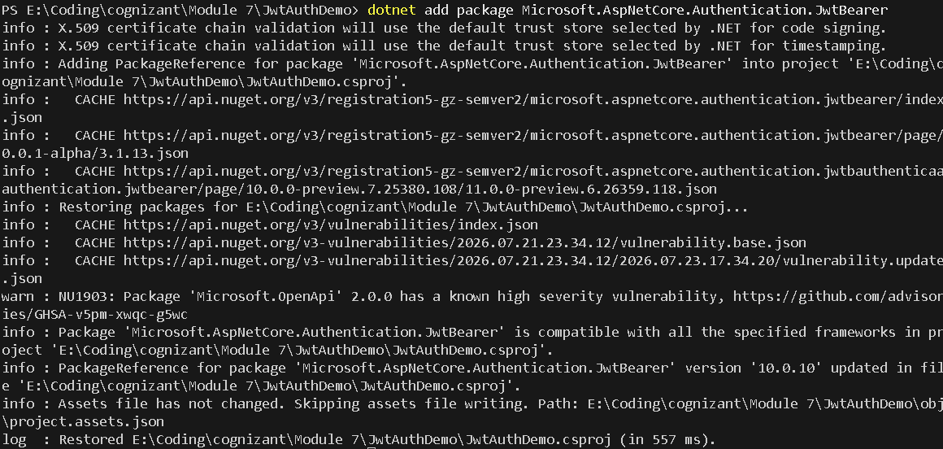

Step 3: Add User model and login endpoint
LoginModel.cs
namespace JwtAuthDemo.Models
{
public class LoginModel
{
public string Username { get; set; } = string.Empty;
public string Password { get; set; } = string.Empty;
}
}

Step 4: Generate JWT token upon successful login
AuthController.cs
using System.IdentityModel.Tokens.Jwt;
using System.Security.Claims;
using System.Text;
using JwtAuthDemo.Models;
using Microsoft.AspNetCore.Mvc;
using Microsoft.IdentityModel.Tokens;

namespace JwtAuthDemo.Controllers
{
[ApiController]
[Route("api/[controller]")]
public class AuthController : ControllerBase
{
private readonly IConfiguration _configuration;

public AuthController(IConfiguration configuration)
{
_configuration = configuration;
}
[HttpPost("login")]
public IActionResult Login([FromBody] LoginModel model)
{
if (IsValidUser(model))
{
var token = GenerateJwtToken(model.Username);
return Ok(new { Token = token });
}
return Unauthorized();
}
private bool IsValidUser(LoginModel model)
{
// Sample credential validation for testing
return !string.IsNullOrEmpty(model.Username) && model.Password == "password123";
}
private string GenerateJwtToken(string username)
{
var claims = new[]
{
new Claim(ClaimTypes.Name, username)
};
var key = new SymmetricSecurityKey(Encoding.UTF8.GetBytes(_configuration["Jwt:Key"]!));
var creds = new SigningCredentials(key, SecurityAlgorithms.HmacSha256);
var token = new JwtSecurityToken(
issuer: _configuration["Jwt:Issuer"],
audience: _configuration["Jwt:Audience"],
claims: claims,
expires: DateTime.Now.AddMinutes(double.Parse(_configuration["Jwt:DurationInMinutes"] ?? "60")),
signingCredentials: creds
);
return new JwtSecurityTokenHandler().WriteToken(token);
}
}
}

Step 5: Secure an endpoint using [Authorize]
using Microsoft.AspNetCore.Authorization;
using Microsoft.AspNetCore.Mvc;

namespace JwtAuthDemo.Controllers
{
[ApiController]
[Route("api/[controller]")]
public class SecureController : ControllerBase
{
[HttpGet("data")]
[Authorize]
public IActionResult GetSecureData()
{
return Ok("This is protected data.");
}
}
}

